# Problem Statement : Personality Profile Prediction.

**Objectives :**

Predicting personality based ona simple dataset which includes nature, intuitiveness, decision making, character. We mainly deals with one is perceiving or judging mentally or not.

**Methodology :**

To obtain the expected gain we have chosen two classifier, those are given below –

* K-STAR
* PART

**K-Star :** K* is an instance-based classifier, that is the class of a test instance is based upon the class of those training instances similar to it, as determined by some similarity function.

**PART :** PART uses partial decision trees to generate the decision list that is shown in the output, but only this final list is what is used to make classifications. So there is no need to consider the partial trees that are generated during the learning process, just use the list of rules that is presented by WEKA.

**Result Analysis :   
  
K-Star Algorithm :**

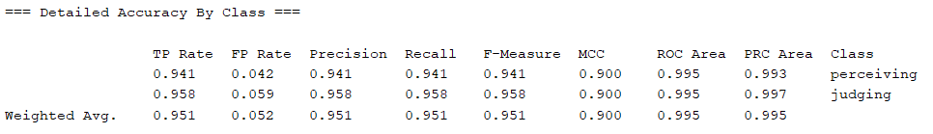

**Figure : Training Set Analysis.**

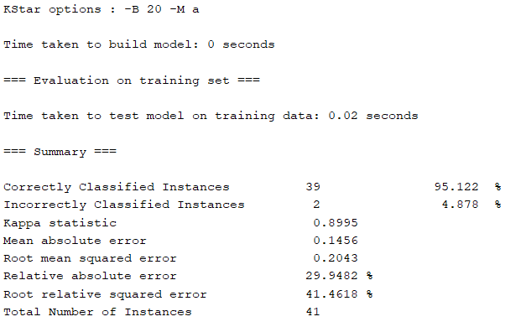

**Figure : Training Set Accuracy.**

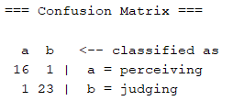

**Figure : Training Set Confusion Matrix.**

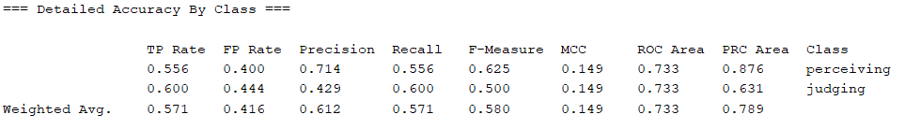

**Figure : Testing Set Analysis.**

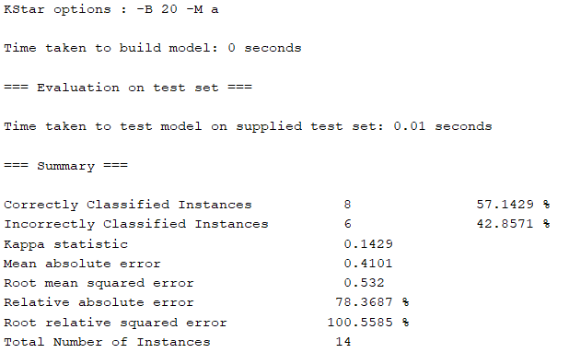

**Figure : Testing Set Accuracy.**

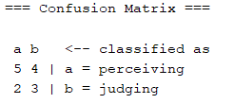

**Figure : Testing Set Confusion Matrix.**

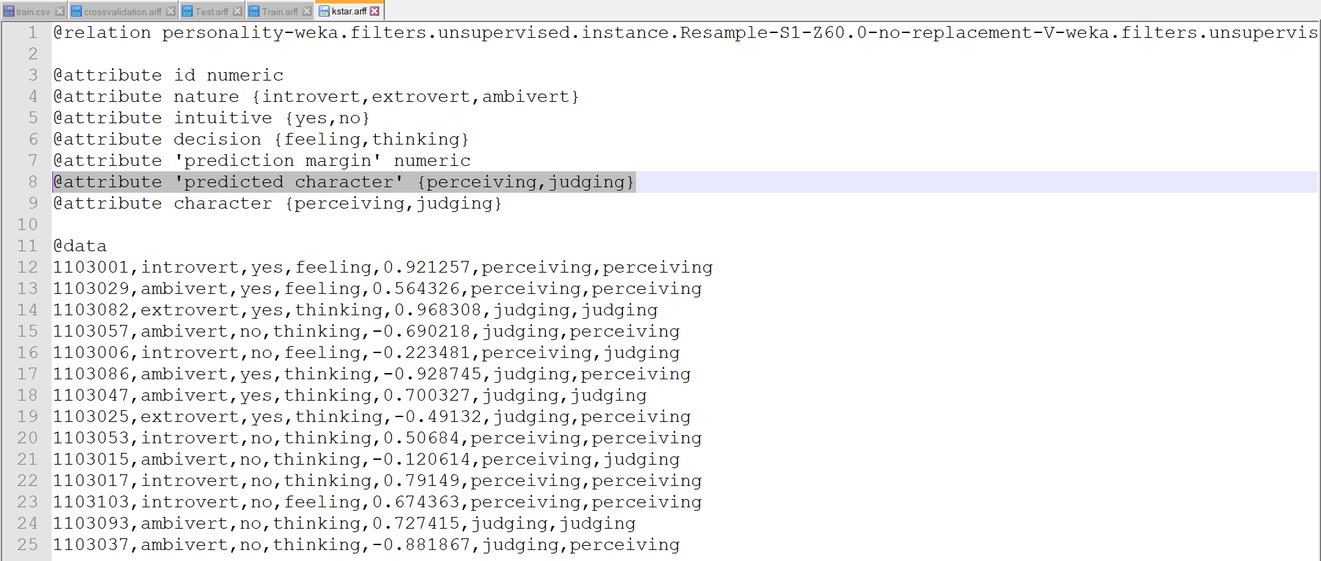**Figure :** Result (K-Star).

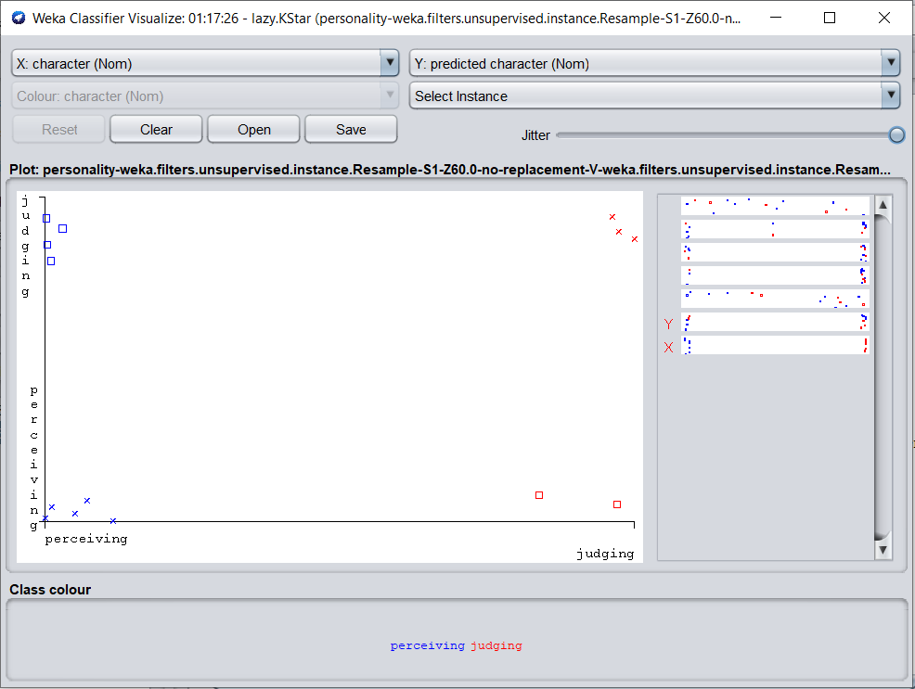

**Figure :** Classifier visualization (K-Star).

**PART Algorithm :**

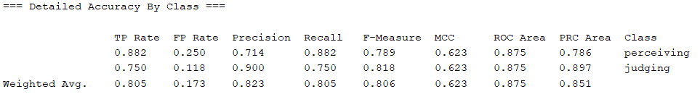

**Figure : Training Set Analysis.**

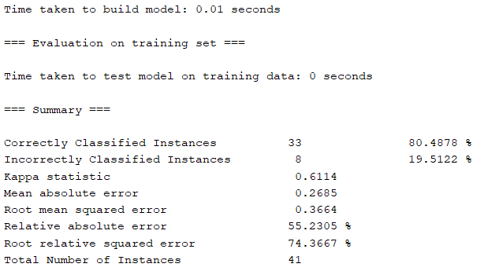

**Figure : Training Set Accuracy.**

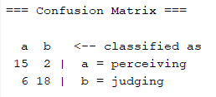

**Figure : Training Set Confusion Matrix.**

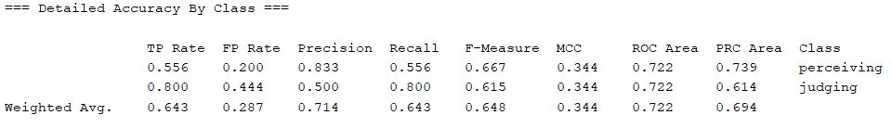

**Figure : Testing Set Analysis.**

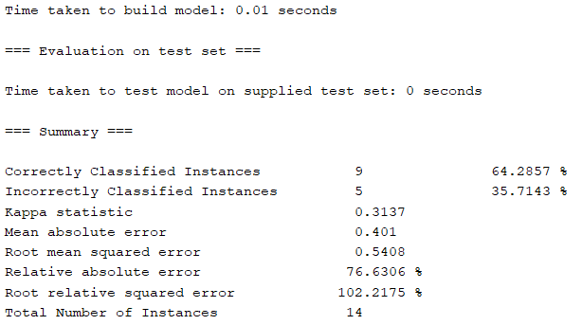

**Figure : Testing Set Accuracy.**

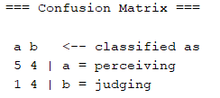

**Figure : Testing Set Confusion Matrix.**

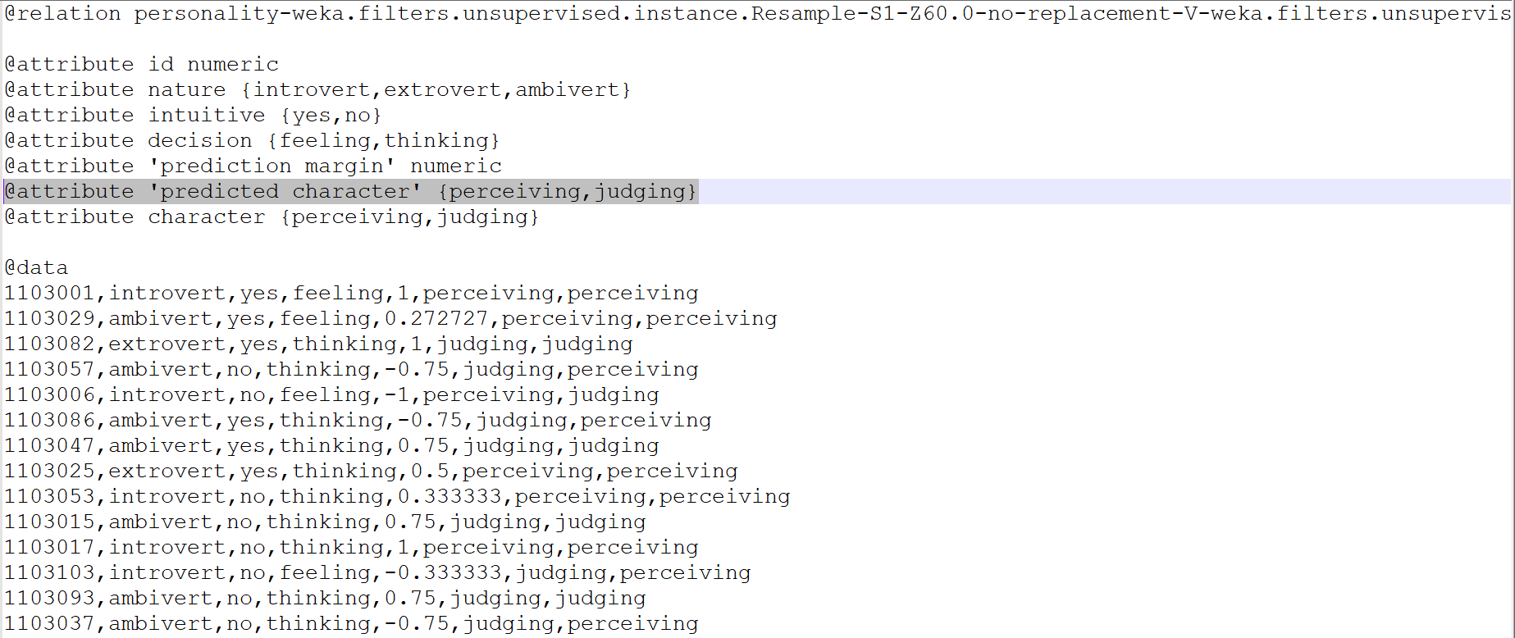

**Figure :** Result (PART).

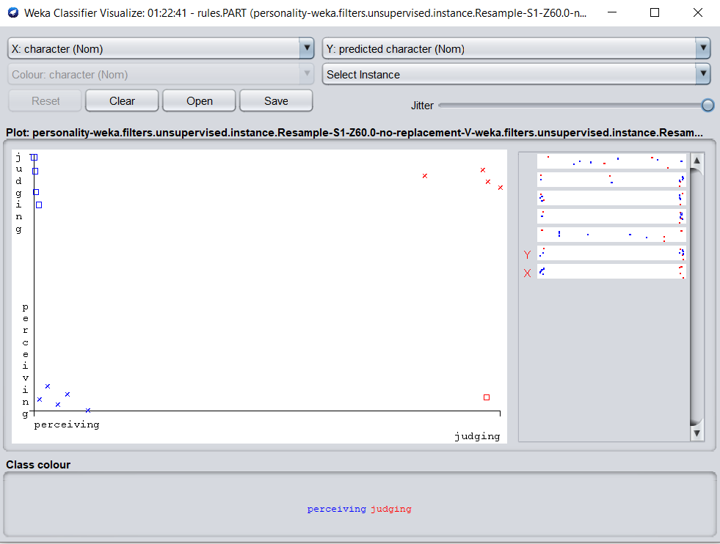

**Figure :** Classifier visualization (PART).

**Comparison :**

In our dataset the dominating portion of dataset consists of ambivert in nature, not intuitive , decision making approach is thinking based and characters are based on judging mentality.

After the analysis we find that in PART algorithm we get better result in testing process.

**K-Star**  **PART**

Correctly Classified 57.122% 64.2857%

Incorrectly Classified 42.857% 35.7143%

**Discussion :**

Since we have used and checked several classifiers we reach in a decision that for this particular dataset PART gives better result. We also add that the data used to train and test the model does not represent the overall amount of personalities worldwide. We have just used the student types of CSE 3rd batch of Bangladesh Army international University of Science & Technology. The outcomes are the flashes of personality based on perceiving persona and judging persona.